
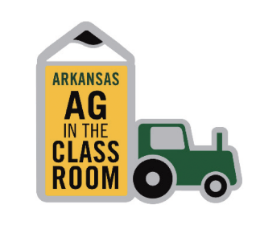
Ag in the Classroom
Outdoor Classroom
Garden Grant Program
The Outdoor Classroom Garden Grant Program helps students discover the important role agriculture plays in their everyday lives. Agriculture is much more than farming. It includes producing food, fiber, and fuel; forestry products; and stewardship of natural resources. Through hands-on garden projects, students can explore the connections between agriculture, conservation, wildlife, nutrition, and their local communities.
Because much of Arkansas’ wildlife depends on private lands, including farms and timberlands, these outdoor learning spaces provide a unique opportunity for students to understand how agriculture and nature work together. Whether growing crops, vegetables, fruits, flowers for educational use, or managing approved livestock projects, participants gain practical experience while learning about the relationship between agriculture, the environment, and society.
Eligibility and Program Requirements
Applications are open to schools, FFA chapters, 4-H clubs, and nonprofit organizations that meet the following requirements:
- Schools must have a minimum average daily attendance of 100 students.
- The garden project must be located on or adjacent to the school or organization site.
- A farmer volunteer, preferably a county Farm Bureau board member, must serve as a project advisor and resource person.
- Teacher involvement is required throughout the project. Parent and community involvement is strongly encouraged.
- Projects must include agricultural crops such as corn, wheat, rice, soybeans, vegetables, fruits, cut flowers, or approved livestock projects, including bees.
- Funding is intended for educational agricultural projects and may not be used for decorative landscaping, bedding flowers, butterfly gardens, or nature trails.
Reporting Requirement
Recipients are required to submit a short status report describing how grant funds were used. Photos and/or videos of the project are strongly encouraged. The project does not need to be completed at the time of reporting. Reports are due by June 1, 2027, and submission of this report is mandatory for all grant recipients.
Funding Information
- Applications will be accepted November 2, 2026 through January 15, 2027.
- Grants are awarded on a matching-funds basis, meaning applicants must secure matching support for the project.
- Funding awards are available up to:
  - $500 for new garden projects
  - $250 for existing or ongoing garden projects
Matching contributions may include:
- Cash donations from businesses, organizations, or individuals
- School or organization funds
- In-kind contributions such as materials, equipment, supplies, labor, or volunteer services

Apply Here: 2027 Garden Grant Application
Questions
If you have any questions regarding the Outdoor Classroom Garden Grant Program, please contact Donette Spann at 501-228-1222, donette.spann@arfb.com; or Lori Croy at (501) 228-1306, lori.croy@arfb.com.

