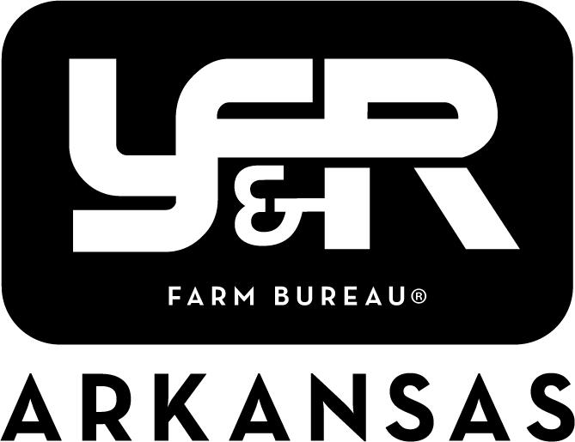

Achievement & Excellence in Ag Award Application
2023 Updated Application Process

There will now be two rounds of Achievement Award (AA) and Excellence in Ag Award (EA) competitions. In the preliminary round, applicants will fill out an Arkansas specific application due March 15th. The top three contestants will be chosen from these applicants and announced at the Young Farmers and Ranchers Conference in February. The second round will require the top three competitors to complete the more extensive American Farm Bureau applications and then participate in either an interview (AA) or presentation (EA). The interviews and presentations will be held, and winners announced during the Officers and Leaders Conference in July.

Deadlines & Announcements

October 10, 2022 – Round one preliminary application available.

March 15, 2023 – Round one preliminary application due.

May – Top three in each category announced.

June 30, 2023 – Top three round two applications due.

July (Officers & Leaders Conference) – Interviews/presentations for the top three in each category held Thursday morning. Winners announced during general session.

