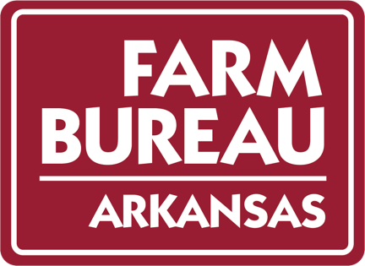

ARKANSAS FARM BUREAU FEDERATION
POULTRY DIVISION
Wyndham River Front
NORTH LITTLE ROCK, ARKANSAS
JANUARY 31, 2023

9:30 a.m. Call to Order – Chris Meador, Chairman

Invocation/Pledge of Allegiance

Introductions

Previous Meetings Minutes

Policy Development Guidebook/ Policy

Update on board recommendations (if necessary)

9:45 a.m. Jada Thompson – University of Arkansas

10:30 a.m. Discussion

Board Recommendations

Commodity Priorities

11:30 a.m. Adjourn

