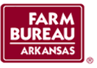
Young Farmer & Rancher Discussion Meet Application

Applicant Name:

Spouse’s Name:

Address:

City & State:

Zip Code:

Phone:

Email:

Date of Birth:

County:

Member#:

Please email application to yfr@arfb.com

Discussion Meet questions, resource materials, and other information can be found on our website, www.arfb.com under the Leadership Portal and Young Farmers and Ranchers tabs.

Deadline for the 2020 Application is July 10, 2020.

